Contains information about complex concepts and /or requires technical knowledge to get the most out of the article. Aimed at the more experienced / ambitious ICT manager or accidental techie.

Working Together - Your Apple Mac and Microsoft Windows

Lasa Information Systems Team

One barrier to using an Apple Mac in the office has been a lack of compatibility between Mac computers and Windows fileservers and Windows Exchange Servers. Apple Mac’s have traditionally been associated with education and creative arts, rarely breaking through into the world of the Windows dominated office.

However, that has changed with the introduction of Apple OS 10.4. In this article, we’ll provide an easy to follow, step by step guide for those wanting to connect a Mac to a Windows network and Exchange server.

For ease of use, this tutorial has been broken-down into 4 parts:

- Connecting your Apple Mac to a Windows fileserver
- Using other tools to connect to Windows computers
- Connecting your Apple Mac to a Windows network printer
- Connecting your Apple Mac to Windows Exchange Server

We recommend that the steps in the tutorials be undertaken by a Systems Administrator or your IT support company.

Connecting your Apple Mac to a Windows fileserver

What you’ll need:
Mac OS 10.4 or higher
Microsoft Office 2004 for Mac
Windows Server 2000 or 2003
Windows Server Administrator permissions
Mac services for Windows Server
Mac Print services for Windows Server
Apple Talk for Windows Server

As the price of Apple Mac’s has fallen, more and more people have thought about buying one for their office. Macs after all have a reputation for reliability, require less IT support, and well……just look so good on the desk.

However, more than one systems administrator has given up after failing to connect a Mac to the Windows fileserver. Much of this is do with Apple Mac and Microsoft Windows using different technologies and protocols to communicate.

The latest release of Mac OS 10.4 and some handy tools from Microsoft now makes the Mac an almost equal player in a windows server network, and a very attractive buying proposition for IT administrators. Just to show how easy it has become, this whole article was written on an iMac, connected to the Lasa fileserver running Microsoft Small Business Server 2000.

Benefits of connecting a Mac to a Windows fileserver
Mac OS 10.4 now includes a variety of technologies that enable it and Windows to work seamlessly together. This is good news for a number of reasons, as we can now:

- Integrate Mac computers into Windows networks that use Active Directory, Microsoft Exchange, and Kerberos
- Access files on Windows file servers or make files on a Mac available to Windows users
- Exchange email (including attachments) with Windows users
- Share the same network with Windows PCs using dial-up, Ethernet, or 802.11b/g (Wi-Fi, AirPort Extreme) wireless connections
- Print to a Windows network printer or share a Mac printer with Windows users

Before we get on to the actual nuts and bolts of connecting your Mac to the Windows fileserver, it’s necessary to take a brief look at how computers communicate over a network and how Windows authenticates and manages user accounts.

Sharing files with Windows servers and PCs
Windows PCs and servers use a networking protocol known as SMB/CIFS to talk to each other. Mac OS 10.4 uses an open source protocol called Samba to connect with a Windows server or PC that has file sharing turned on. This means that your Mac and Windows PCs can now open, edit, save, and copy the same files using a folder or directory that’s common to both of them.

Windows managed networks
Active Directory in Windows (or Open Directory in Mac OS X) stores information about user accounts, computers and servers in a central directory. This allows users to have a single account for accessing all servers on the network and enables people to use one account to log in at a workstation (and for administrators to control which workstations allow user login).

Active Directory also allows administrators to manage the user environment for specific groups of users or computers, control printer and application access, and set permissions and access restrictions for resources stored on computers throughout a network.

Now we’ve got these three concepts out of the way, it’s time to configure the Windows fileserver.

Getting started
Before we start, the first step is to get your Systems Administrator or IT Support Company to enable Macintosh Services, Mac Print services and Apple Talk on your organisation’s Windows fileserver.

Your System Administrator will also need to configure the Windows User Authentication Module. You’ll need this module for the Mac to successfully logon to the Windows fileserver. Download it from: http://www.microsoft.com/mac/otherproducts/otherproducts.aspx?pid=windows2000sfm

Go to: http://support.microsoft.com/ and search for “services for macintosh”

Or follow this link for pages on configuring your windows fileserver for macintosh services.
http://technet2.microsoft.com/WindowsServer/en/Library/d3221b9c-63da-49df-8535-8d23360b66d81033.mspx?mfr=true

Step 1:
Presuming everything’s been set up on the Windows fileserver, we now have to set up the Mac by configuring the Network and Sharing settings so that it can find and talk to the Windows fileserver. Go to your Mac and fire up System Preferences, located on the dock menu at the bottom of your screen.

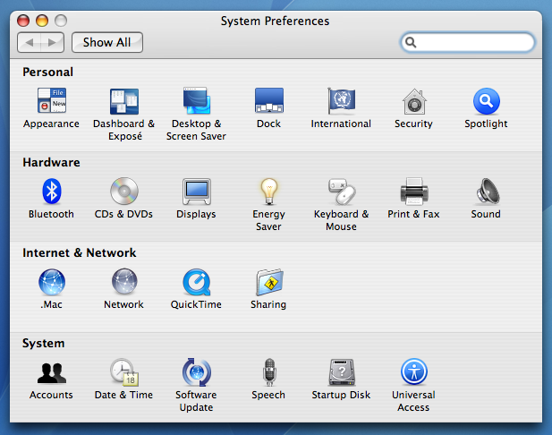
(Step 1 System Preferences screen)

If you’re going to connect to the Windows network via a wired Ethernet connection, make sure that the Network dialogue box is showing the settings for Built-in Ethernet. From here, click on the TCP/IP tab and enter your network’s Windows domain, usually local, into the search domains box at the bottom.

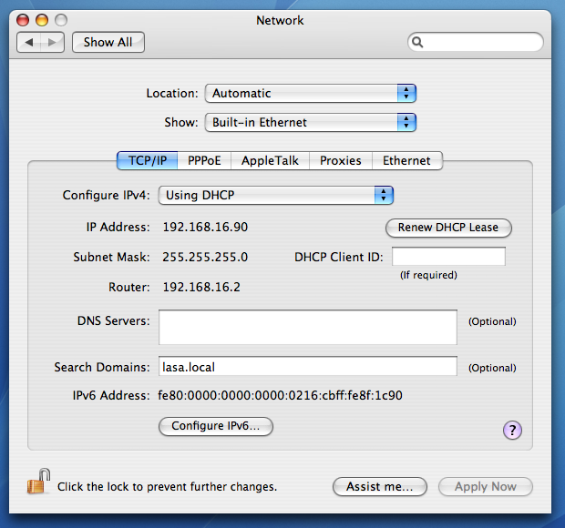
(Step 1. Network, TCP/IP configuration screen)

Ignore the PPPoE tab, it’s for configuring a direct connection to the Internet. In this tutorial we’re assuming that the Windows fileserver manages connections from the network to the Internet, which we’ll deal with later on the Proxies tab.

Step 2:
Now click on the AppleTalk tab and check the Make Apple Talk Active box.

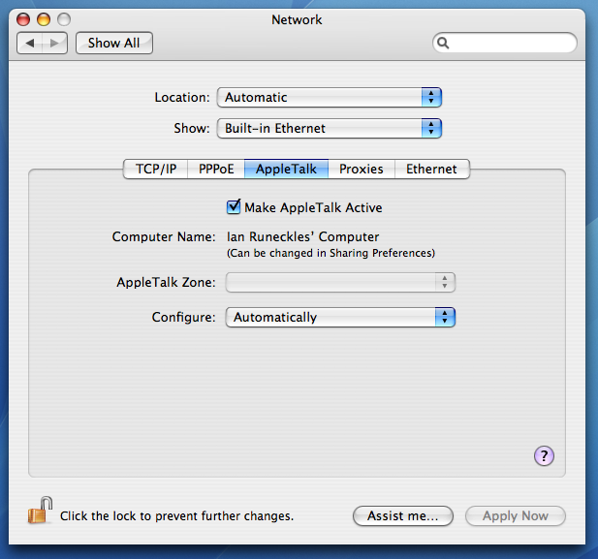
(Step 2. Network, Apple Talk configuration screen)

Step 3:
Now click on the Proxies tab and configure the Web Proxy (HTTP) server with the IP address for your Windows fileserver. This will be probably be an address that starts with 192.168.xx.xx. Configuring the proxy server address tells your Mac to where to connect the Windows fileserver, which controls authentication and access to the local network and Internet. If you don’t do this, the Mac will try and fail to make a direct connection to the network, which isn’t allowed because the Windows fileserver controls this!

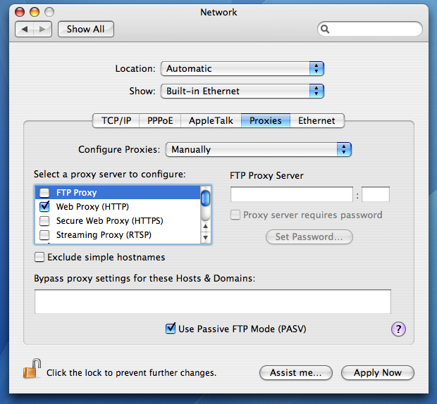
(Step 3. Network, Proxies configuration screen)
Take the same proxy server settings you used for HTTP and enter for FTP, HTTPS and RTSP.

Step 4:
Now we have to set up Windows file-sharing so that Windows servers and PCs can access shared folders on our Mac. Tick the Windows Sharing box and notice that at the bottom of the screen it now gives an IP address for Windows users to connect to your Mac.

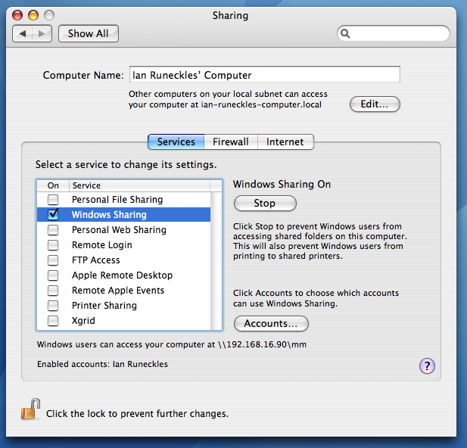
(Step 4. Network, Apple Talk configuration screen)

Also notice that it tells you which accounts are enabled for Windows Sharing, as you may not wish to grant this to every user account on the Mac.

Step 5:
Now we’re ready to look at configuring Directory Services on the Mac, the bit that authenticates and logs users onto the Windows network.

Click on Finder ➔ Applications ➔ Utilities ➔ Directory Access

On the Services tab, enable Active Directory, AppleTalk and SMB/CIFS. Of these three services, only Active Directory needs any tweaking.

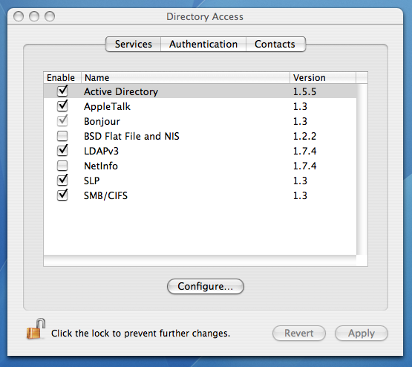
(Step 5. Directory Access, Services configuration screen)

AppleTalk and SMB/CIFS will automatically pick up the correct settings from the Windows fileserver after Active Directory has been configured.

All you have to do now is enter the domain and name of your fileserver. Ask your System Administrator or IT Support Company for this. Make sure the check boxes are set the same as in our example.

Once you’ve got the correct settings, click on the Bind button. At this point you will be asked for the Windows network administrator name and password to begin the process of binding the Mac to the Windows Active Directory.

Once the binding process completes you will now be able to use your Windows network login details to logon to the Mac, and access network drives from the Mac.

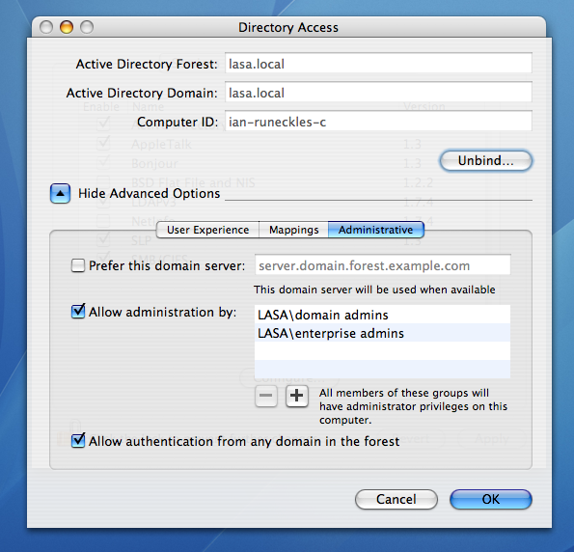
(Step 5. Directory Access, Administrative options screen)

To see the changes, restart your Mac and you’ll notice a new network login icon on the Mac’s login screen.

Connecting to shared folders on the Windows server
Now that your Mac is connected to the Windows fileserver, you’ll want to get at your files. Make sure you’ve logged in to the Mac using your Windows network login details.

Now click on Finder ➔ Network. At this point, the Finder should be showing the Windows fileserver and a list of shared folders that you have access to. Since you have only one network login ID, the same user permissions will apply whether you’re logged in on a PC or a Mac. Browse to the folder you wish to connect to, click connect, and you can now access the files inside.

Using other tools to connect to Windows computers
In this section we show some other useful tools for connecting to Windows computers.

Remote Desktop Client
Using Remote Desktop Connection Client for Mac OS X, you can connect from your Mac to a Windows machine and work with programs and files directly on that computer.

You can also copy and paste information between Macintosh and Windows programs, print from Windows programs to the printers connected to your Macintosh and use Windows terminal servers to provide groups of Macintosh users in the workplace with access to Windows-only programs.

This last feature can be useful if you need to work with Windows only programmes, but don’t have direct access to a Windows computer on your local network.

Step 1:
Download and install the free Remote Desktop Client from: http://www.microsoft.com/mac/otherproducts/otherproducts.aspx?pid=remotedesktopclient

Step 2:
You now need to configure the target Windows machine to accept remote desktop connections. On the Start menu, click Control Panel ➔ System, then click the Remote tab, and then select the Allow users to connect remotely to this computer check box.

Step 3:
You now need to enter the IP address or network name for your Windows computer, followed by your login name and password. If you need to enter a local network domain name, ask your System Administrator about this.

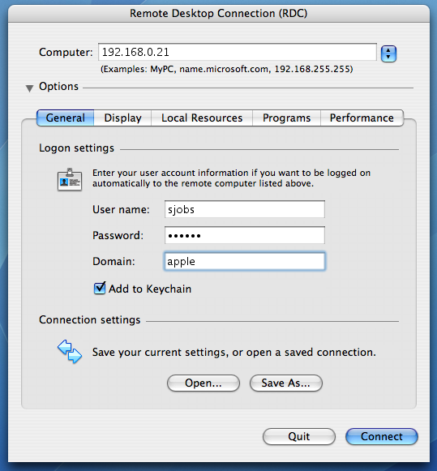
(Remote Desktop Connection – connect to Windows computer login screen)

Before you hit connect, remember that your Mac will now be controlling the Windows PC across the local network. To reduce the load on the local network, browse the tabs for Display, Local Resources, Programs and Performance. These tabs allow you to tweak the size of the window and number of colors that the Remote Desktop Client will display, as well as connecting to devices attached to the Windows PC and executing programs on the Windows PC.

Step 4:
Once connected, the Remote Desktop Client will open a new window on your Mac, showing the desktop on your Windows PC.

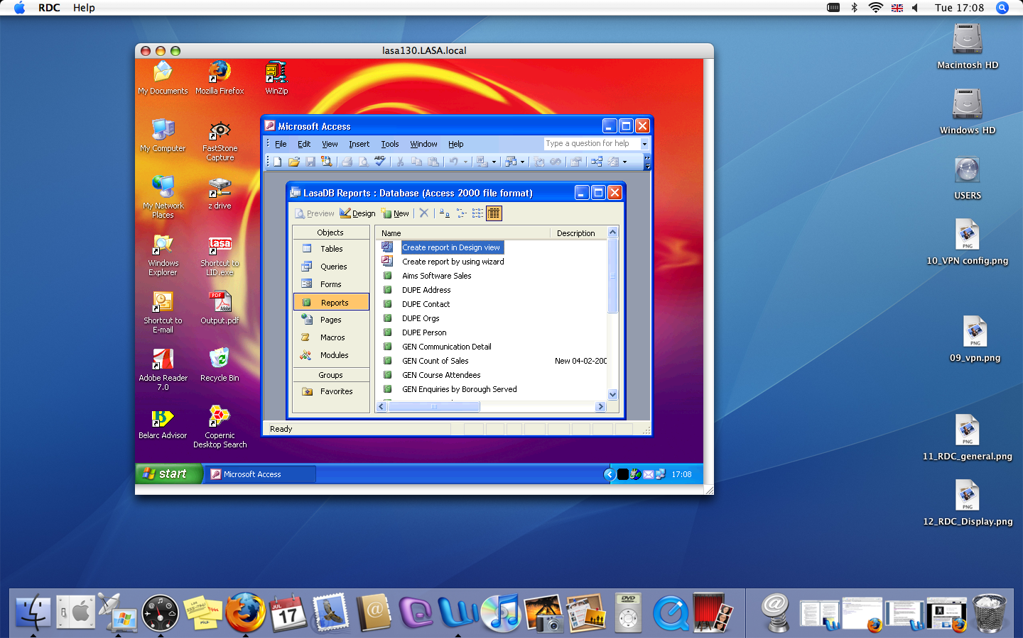

Connecting to a Windows fileserver using VPN
If you work from home using a Mac, you can also connect to your office’s Windows network by using VPN. Virtual private network (VPN) is a private communications network used by companies to communicate securely over public networks, such as the Internet. Using OS X’s built-in VPN tools, you will be able to open your documents and email safely and securely, as if you were in the office.

Step 1:
To access OS X’s built-in VPN tools, click on Applications ➔ Internet Connect.

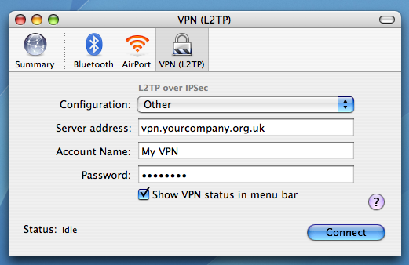
(Internet Connect, VPN screen)

Step 2:
Click the VPN icon in the toolbar. Then choose the type of VPN connection, either "L2TP over IPSec" or PPTP. Your network administrator will advise you on which protocol to use. Finally, choose a configuration from the Connect pop-up menu, and click Connect.

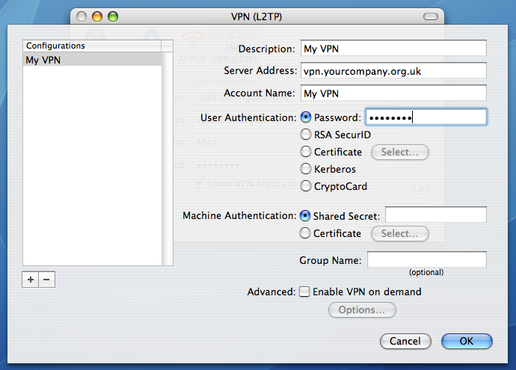
(VPN configuration screen)

Step 3:
Notice the VPN icon on the Finder toolbar. This is useful for keeping track of time connected to the VPN server. Clicking on the VPN icon brings up quick options to disconnect or connect to a different VPN server.

Step 4:
Now you’re connected to the office VPN server, you’ll need to connect the office fileserver itself. Do this by pressing ⌘+K to bring up the Connect to Server dialogue box. Now enter the path to your server and click Connect.

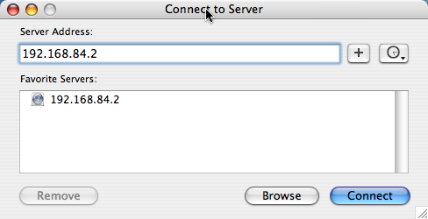

You’ll then be prompted for your usual login and password for the Windows network.

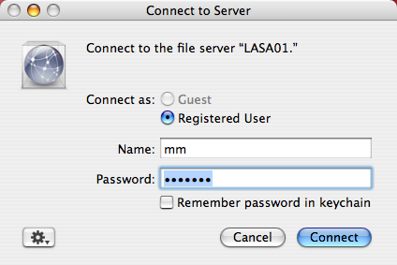

You should now be able to see the directory you connected to appear in the left navigation panel of the Finder.

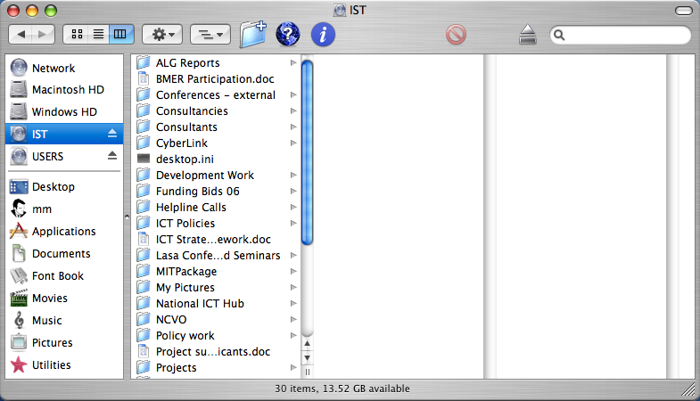

Connecting your Mac to printers on a Windows network

Now that you’ve completed the previous tutorial on setting up the Windows fileserver and have successfully connected your Mac, and can share files and folders, the logical next to step is to connect with Windows network printers.

This article assumes that you have successfully completed the tutorial on connecting your Mac to the Windows fileserver.

What you’ll need:
Mac OS 10.4 or higher
Microsoft Office 2004 for Mac
Mac Print services for Windows Server

Step 1:
Mac Print services for Windows Server is installed and configured on the Windows fileserver. The Mac file service and AppleTalk service should already be installed and configured on the Windows fileserver. Ask your System Administrator or IT Support Company to do this.

Step 2:
Now make sure you install the Mac OS X drivers for the printers you wish to connect to on to your Mac.

To do this, you’ll either need the drivers CD that came with the printer or check the manufacturer’s website for the latest OS X drivers for your printers. Install the latest drivers on to your Mac and then click on Finder ➔ Applications ➔ Utilities ➔ Printer Setup Utility

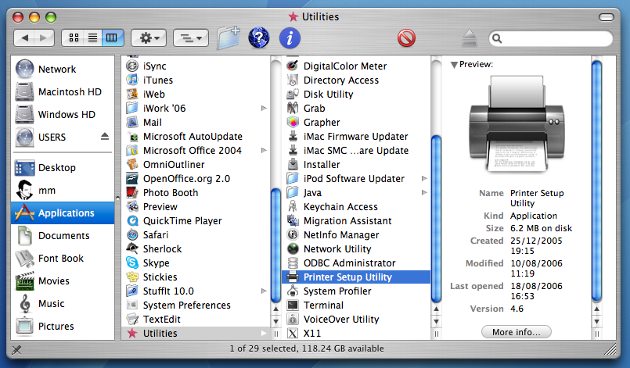
(Finder, Utililities, Printer Setup Utility screen)

Step 3:
Click on Printer Setup Utility, which brings up the Printer List dialogue box. Click on the Add icon, which will now bring up a list of printers attached to the network.

Step 4:
Navigate to the printer you wish to connect to. In this example we’re going to add the Kyocera FS-C5020N printer, also known as the KM55E27E in the list of printer names found by our Mac.

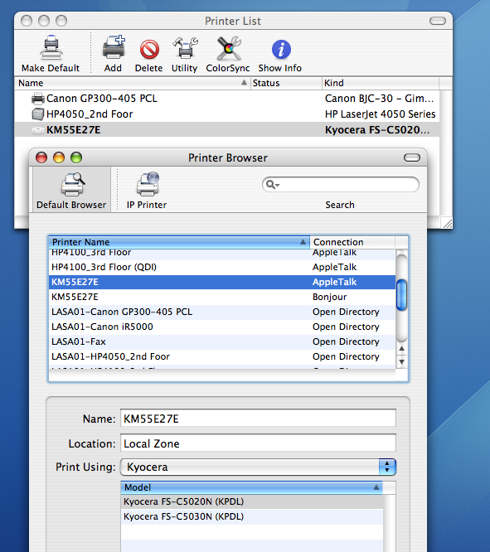
(Printer Browser – choose printer screen)

Don’t worry about the different connection types – Bonjour and AppleTalk are both protocols that allow devices like printers and scanners to announce themselves directly to the local area network. An Open Directory connection type just means that you’ll be connecting to that device via the Windows fileserver.

Once, you’ve found the printer you need, click on it. Now find the drop-down menu for Print Using: This will present you with a list of drivers for your printer, click on the correct driver, click ok and close the Printer Browser screen. Back on the Printer List dialogue box, set this printer as your default printer. Test the printer by opening a Word document and printing it off.

Connecting your Mac to Windows Exchange Server

The Mac’s previous lack of connectivity to Windows Exchange Mail servers was a major barrier to many people taking up Macs in the office. If people couldn’t connect to their Outlook mail, calendar and address book from a Mac, then what was the point in having one in the office?

Apple’s OS 10.4 and some patches from Microsoft for its Office for Mac 2004 suite have pretty much resolved that, and this tutorial shows how easy it can be to connect your Mac to a Windows Exchange Server so that you can enjoy all the benefits.

This article assumes that you have followed successfully the tutorial on connecting your Mac to the Windows fileserver and local network.

What you’ll need:
Mac OS 10.4 or higher
Microsoft Office 2004 for Mac and latest patches from Microsoft
Windows Exchange Server 2000 or 2003
Windows Exchange Server Administrator permissions

Microsoft Exchange mail and contacts
The latest release of Entourage, the Mac version of Outlook, provides mail, calendar and address book functionality. Entourage works with the Microsoft Exchange mail server and enables you to schedule meetings, synchronise your calendar and address book with the server, and look up email addresses in the server’s global address list.

In this tutorial we’re going to set up our Exchange Server account on the Mac using Entourage. To get started you’ll need Microsoft Office 2004 for Mac and the latest patches from Microsoft which fix some issues with Exchange Server.

Step 1:
Download and install the latest patches for Office 2004 for Mac at: http://www.microsoft.com/mac/downloads.aspx

You can also use the Microsoft AutoUpdate utility, located in the Applications folder of your Mac to schedule automatic updates of Office for Mac on a weekly or monthly basis.

Microsoft also supplies a Resource Kit to help you deploy Office 2004 for Mac on your network.
http://www.microsoft.com/mac/resources/resources.aspx?pid=resourcekits

Step 2:
Make sure that you know the Windows Domain for your network and the file path to the Exchange Server, or this won’t work. Then fire up Entourage, click on File ➔ New ➔ Email Account. Tick the box marked My account is on an Exchange server.

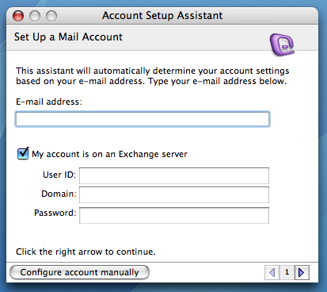
(Entourage, Account Setup Assistant)

Enter your email address, user ID, network Domain, password and click the right arrow. Ask your System Administrator if you don’t know any of these details.

Step 3:
If the automatic configuration fails, you’ll be presented with this screen. Click on the right arrow at the bottom to move on to enter details for the Exchange server and LDAP server.

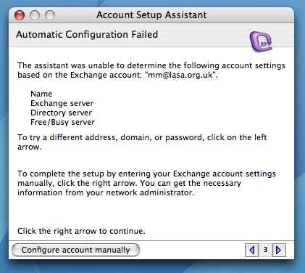
(Entourage, Example of configuration failed screen)

Step 4:
Now enter your network domain, the path to the Exchange server and the path to the LDAP server. These should both be the same. Your systems Administrator should have these details, or you may have to experiment with getting the right paths.

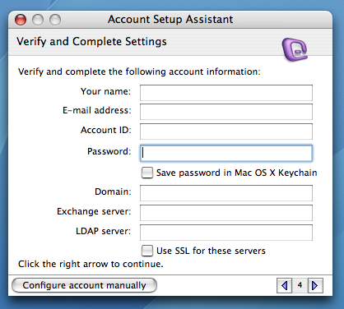
(Entourage, Verify and Complete Settings)

Make sure Save password is checked and click on the right arrow to go to the next screen.

Step 5:
Click on Verify My Settings and watch as Entourage binds with the Exchange server. If you’ve entered the wrong details for any of these elements, it will be flagged up in red for you to try again.

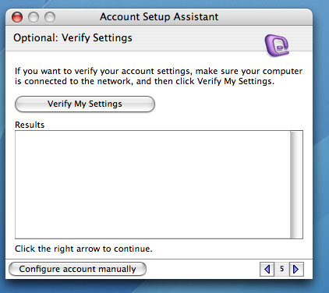
(Entourage, Verify My Settings screen)

If you’ve entered the correct details, the Results tab should indicate a successful connection to the Domain controller, the Exchange Server, and LDAP server, and it will now begin importing your mail, calendar and address book from the Exchange Server.

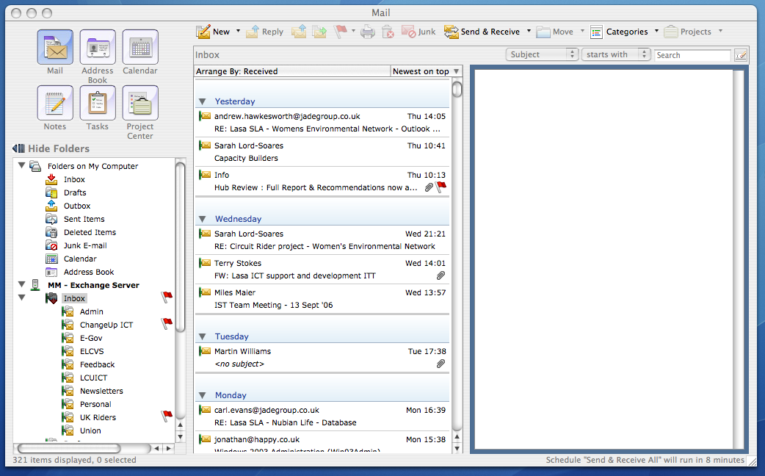
(Entourage, view of successfully configured Exchange Server email account)

Remember that if you delete mail from your Exchange account whilst working in Entourage, this will be mirrored the next time you connect to Outlook. The same applies for making any changes to your Exchange calendar and address book.

Security
Macs are renowned for being reasonably secure. However, there’s always the chance that mail sent to your Mac could infect the Windows network. We recommend investing in a firewall and anti-virus product. Intego’s Internet Security Barrier – Anti-spam Edition for £70 will do a good job of protecting your Mac. See http://www.intego.com/isb/

Summary
In this tutorial we set out to show that one of the biggest barriers to using Macs in the office – its connectivity to a Windows Exchange Server – can be overcome with a modest amount of effort and expertise. The traditional barriers between Macs and PCs are beginning to fall and we should expect to see a lot more inter-connectivity in future releases of apple Mac and Windows operating systems.

